User Manual

Team Name: CAG  
Team Members: Christopher Chang (cyc2136@columbia.edu), Gracie Gilbert (gyg2104@columbia.edu), Ahmad Maruf (aim2122@columbia.edu)

Upon landing on our home page, the user will see a search bar with a search button underneath it. As instructed by the text in the search bar, enter a song that you’d like to learn more about.

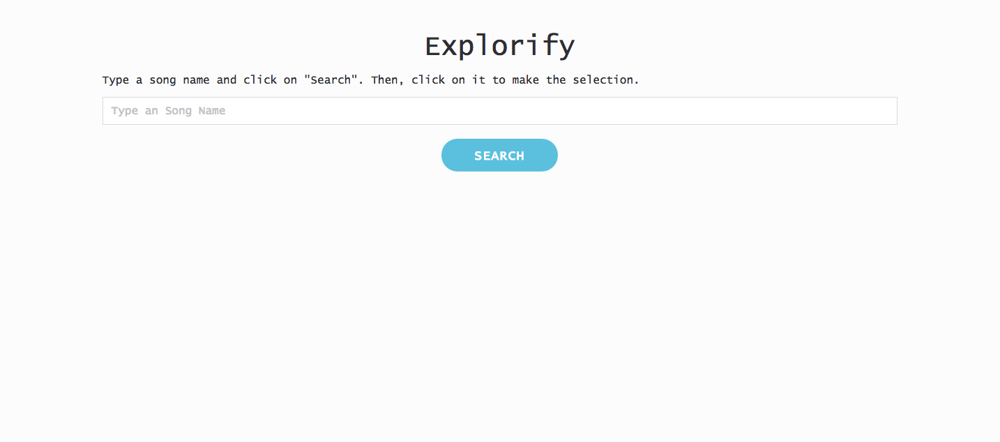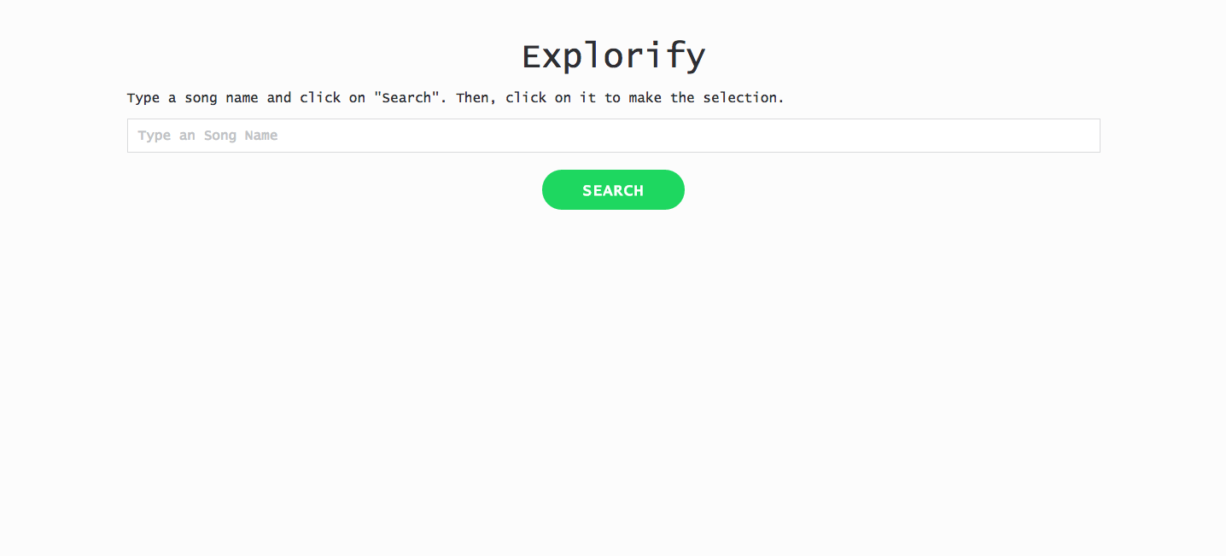

While the theme of our program is blue (#5bc0de), when you hover over the blue (#5bc0de) search button it turns into the Spotify green to let the user know that we are searching for the desired song through Spotify’s API endpoints. As soon as you click search or press the “enter/return” button, you will be redirected to a results page. Here you will find a list of matches with the song that you have typed in. There are several things that you can do from here. If you found that you have erroneously typed in the wrong song, you can easily re-search a song by either clicking the home button found in the top right corner, or the back button found in the top left corner; both will bring you back to the home page.

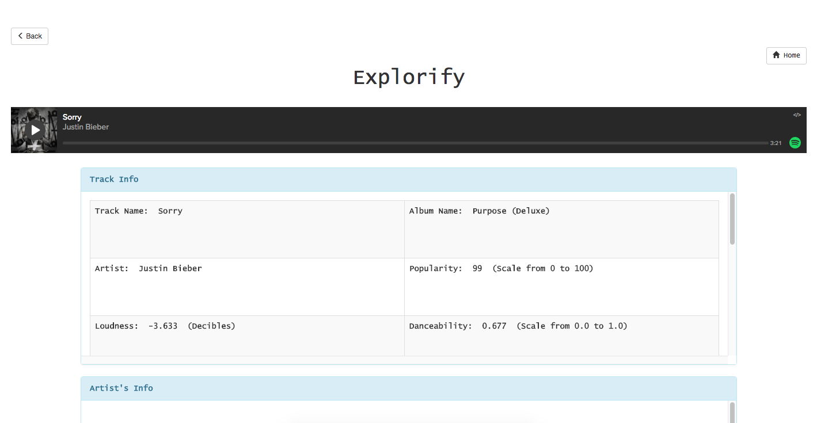

If you did correctly type in the song title that you were looking for, a list of matches will appear on the page. You can scroll through the options and listen to a 30 second preview if desired. Once you have located the exactly song that you were looking for, you can go ahead and press on the “info” button in the right-most column. By doing so, it will redirect you to the third and final page in the user flow, the info page. The info page consists of all relevant information including regarding both the track and the artist.



To get the details of what each of the track descriptors (popularity, danceability, loudness, key, mode, tempo, time signature, energy, liveliness, acousticness, instrumentalness, speechiness, duration) means, simply hover over the descriptor in the info panel and you will see a corresponding pop-up description. From here you can click on links (in blue, just as permalinks are commonly highlighted in blue) that redirects you to the artists site, news sources, blog articles, reviews, etc. To search for another song, you click on the home button. To go back to your previous search results you can press the back button.

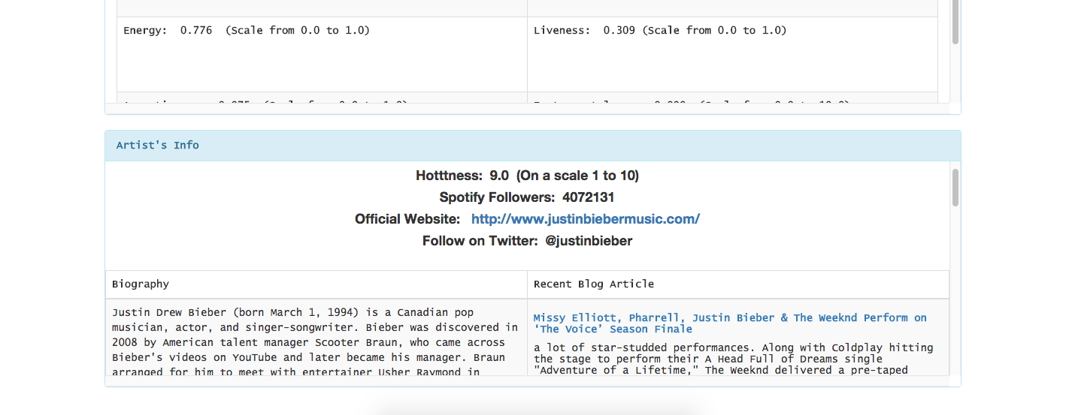

If there are any issues with using our program, please email us at one of the emails listed at the top of the page.